ABSTRACT
This case study investigates the impact of AI learning tools on student performance using a dataset of 50,000 learning sessions. We analyze relationships between tool usage patterns, perceived usefulness, ease of use, trust, and student outcomes, including pre- and post-test scores, task completion, and satisfaction levels.
Exploratory Data Analysis (EDA) is employed to visualize trends and correlations across variables such as session frequency, duration, hints requested, and adaptive difficulty levels. Additionally, sentiment and emotion analysis on student feedback is incorporated to understand learners’ perceptions and attitudes toward AI-assisted learning. The study aims to identify key factors influencing both academic performance and user satisfaction, providing insights for educators and developers to optimize AI tools for effective learning.

INTRODUCTION
Artificial Intelligence (AI) has increasingly become integrated into modern learning environments, offering support through adaptive feedback, personalized recommendations, and interactive assistance. As students engage with AI tools for academic tasks, understanding how these technologies influence learning outcomes becomes essential. With the rapid adoption of AI-assisted platforms, there is growing interest in how usage patterns, perceived usability, trust, and user feedback relate to academic performance and overall satisfaction.
This study explores the effect of AI tool interaction on student learning using a dataset of 50,000 recorded sessions. It examines how factors such as session frequency, duration, task completion, hint usage, and sentiment expressed in feedback contribute to measurable improvement in student performance. Through both statistical analysis and machine learning techniques, the study aims to provide evidence-based insights into how AI tools shape learning experiences and outcomes.

OBJECTIVES:
(1) To analyze student interaction patterns using metrics such as session count, average session duration, and weekly AI tool usage. (2) To evaluate the relationship between AI tool engagement and academic performance through improvement scores, tasks completed, and adaptive difficulty levels. (3) To assess user satisfaction and perception of AI tools by examining perceived usefulness, ease of use, trust, and satisfaction scores. (4) To incorporate sentiment and emotion analysis of text feedback using polarity, subjectivity, sentiment labels, and primary emotion categories. (5) To provide data-driven insights to guide the optimization of AI-assisted learning systems for improved educational outcomes.

METHODOLOGY
The analysis follows a structured approach similar to traditional OLS-based research designs, adapted for multiple linear regression using Python libraries such as pandas, scikit-learn, seaborn, and matplotlib.
(1) Data Collection and Preparation: The dataset contains variables related to AI tool usage, student attitudes, ethical concerns, and academic performance, including pre-test and post-test scores. Data preparation involved handling missing values, selecting relevant numerical predictors, and preparing the dataset for regression modeling using pandas. Exploratory data analysis (EDA) was conducted through seaborn and matplotlib to visualize distributions, correlations, and improvement patterns.
(2) Model Specification and Representation: A multiple linear regression model was selected to examine how AI-related factors, usage frequency, perceived usefulness, trust, and ethical concerns influence post-test scores. The model specifies post-test score as the dependent variable, with predictors representing behavioral, perceptual, and contextual measures of AI tool adoption.
(3) Coefficient Estimation Using Linear Regression: The model was trained using scikit-learn’s LinearRegression. Coefficients were extracted to determine the direction and strength of each predictor’s relationship with student performance. A Lasso regression model was additionally applied to identify the most influential features through regularization and feature selection.
(4) Prediction of Values: The dataset was divided into training and testing subsets. Predictions on the test set were generated to assess how well the model generalizes to unseen data. Metrics such as R² and mean squared error (MSE) were computed to evaluate predictive accuracy.
(5) Interpretation and Visualization of Results: Scatter plots and comparison graphs were produced using seaborn and matplotlib to visualize predicted versus actual post-test scores, as well as improvements from pre-test to post-test. The regression coefficients were analyzed to identify which AI-related factors significantly contribute to student performance. Lasso-selected features further clarified the variables with the strongest explanatory power.

Data
This case study used a Kaggle dataset that focused on the mental health of a student and it contains variables such as Study Satisfaction, Financial Stress, Dietary Habits, Age, Sleep Duration, suicidal thoughts, Family History of Mental Illness, CGPA, Academic Pressure. Which is a good variables for modeling.
Data Preprocessing
Figure 1: Code
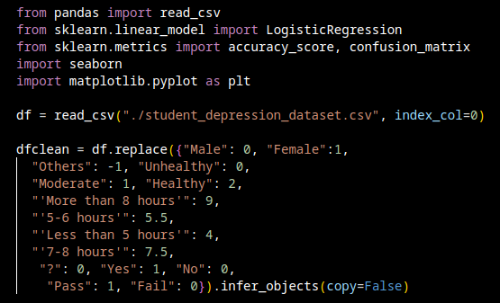
this code is used import required modules and to convert non-integer (categorical) variables into integers is called encoding. This is a critical step before feeding the data into most machine learning models, which typically require numerical inputs.
Figure 2: code that filters out useless variables and only include useful variables.
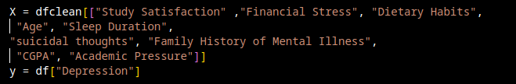
removing irrelevant or redundant variables from the original dataset to improve model performance and interpretability. The goal is to select features that are most predictive of your target (Depression), reducing noise and overfitting.

Data Modeling
Figure: simple modeling code
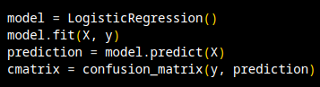
This code trains a logistic regression model on features X and target y, makes predictions on the same data, and evaluates the results using a confusion matrix.

Accuracy
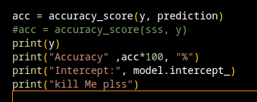
Figure: code to display how accurate the model performance is.
This code is used to display the model accuracy and Intercept to show how the model is performing. With the Accuracy of 84.28%, and Intercept of -1.27157241, it shows that the model is performing quite well.
Visualization
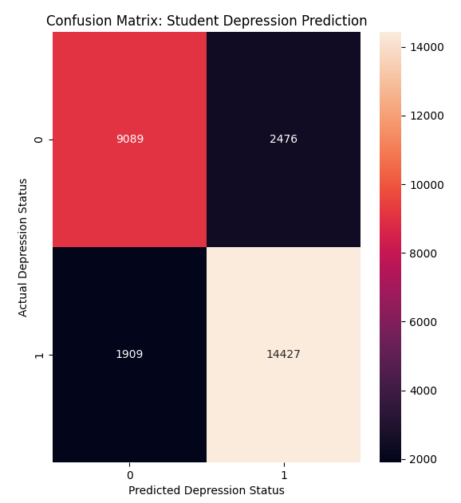
Table 1: Confusion Matrix
Confusion Matrix shows the Actual vs. Predicted values for a classification model, where the x-axis represents the Predicted Depression Status and the y-axis represents the Actual Depression Status. It shows that there is 9098 True Negatives, 14427 True Positives, 2476 False Positive, 1909 False Negatives With Accuracy of 84.28 %. It helps evaluate the performance of the model by comparing how many predictions were correct or incorrect. This matrix helps in understanding errors like false positives (predicting depression when there isn’t) and false negatives (missing actual depression), which is important in sensitive fields like mental
ealth prediction.

Table 2: Students Degree Bar Graph.
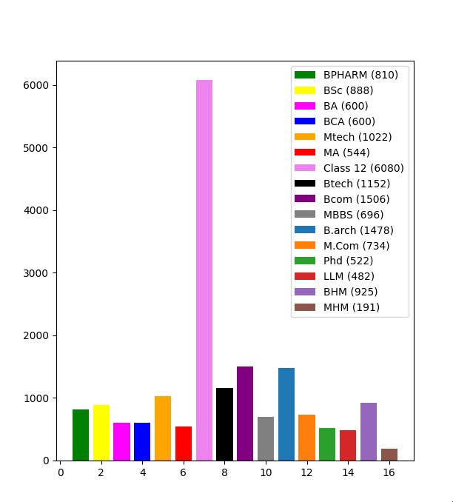

This bar chart displays the number of students from different educational backgrounds. Each bar represents a specific course or level of education, and the height of the bar indicates how many students belong to that category.
"Class 12" has the tallest bar, with 6080 students, meaning it's the most represented group.
Other large groups include:
Bcom with 1506 students
B.arch with 1478 students
Btech with 1152 students
Mtech with 1022 students

Smaller groups include:
MHM: 191 students
LLM: 482 students
PhD: 522 students
Each bar is color-coded and labeled for clarity, with the exact number of students shown in parentheses in the legend. The x-axis shows the categories, while the y-axis shows the student count.

TABLE 3: Gender Bar graph
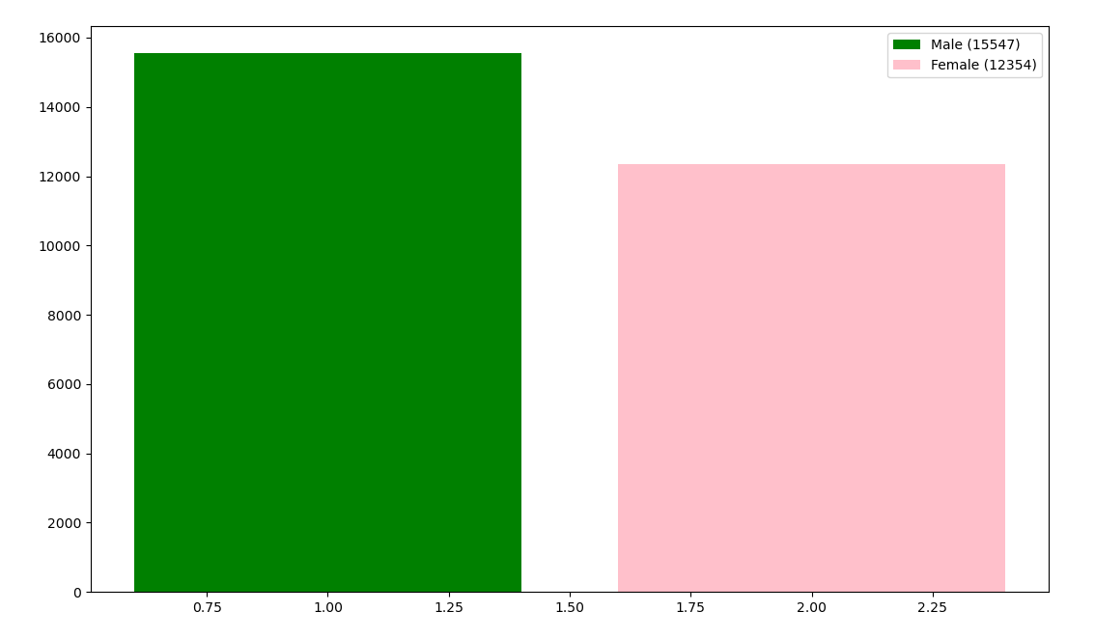
This bar chart was created using Matplotlib to visualize the gender distribution in a dataset. It shows that there are 15,547 males and 12,354 females, with the male bar colored green and the female bar in pink. The chart includes a legend that labels each gender along with their respective counts, making it easy to compare the values at a glance.

Recommendations
Based on the analysis of factors affecting students mental health and academic performance, the following recommendations are proposed to educational institutions, mental health practitioners, and policy developers:
1. Implement Comprehensive Mental Health Support Programs.
2. Institutions should offer accessible and confidential counseling services that address suicidal thoughts, stress, and anxiety. Regular mental health screenings and early intervention programs should be integrated into campus health services.

Introduce Stress Management Workshops
3. Conduct regular sessions on managing academic and financial stress, time management, and coping strategies. These can help students better handle pressure related to CGPA, study satisfaction, and work obligations.
4. Promote Healthy Lifestyle Habits Encourage students to maintain balanced dietary habits and adequate sleep through awareness campaigns, wellness programs, and providing healthy food options in cafeterias. Sleep hygiene education should also be part of student orientation programs.
5. Enhance Academic Flexibility and Support. Reduce unnecessary academic pressure by offering flexible deadlines, academic counseling, and mentorship programs. Creating a supportive academic environment can significantly improve study satisfaction and performance.
6. Provide Financial Assistance and Career Guidance Offer scholarships, part-time job placements, and financial counseling services to reduce the burden of financial stress and work pressure among students.

CONCLUSION
This case study highlights the significant influence of academic, lifestyle, and psychological variables on students' mental health and academic performance. The analysis demonstrates that high academic and financial pressures, inadequate sleep, poor dietary habits, and a family history of mental illness are strongly associated with increased stress levels and suicidal thoughts. Conversely, factors such as study satisfaction, balanced lifestyles, and effective coping mechanisms contribute positively to both mental well-being and academic success.
Recognizing these interconnected factors is crucial for educational institutions aiming to foster a healthier and more supportive learning environment. By implementing targeted interventions and promoting holistic well-being, institutions can play a pivotal role in reducing mental health risks and enhancing the overall academic experience for students.
Ultimately, addressing student mental health is not only a moral imperative but also a strategic investment in their future success and society’s long-term well-being.

REFERENCES
Student depression dataset.
https://www.kaggle.com/code/saifeldeenmohammedm/student-depression-dataset
Case Study Source Codes.
https://github.com/AlieeLinux/case-study

